**MINI PROJECT**

**(2020-2021)**

**Basic financial learning website**

**MID-TERM REPORT**



**Institute of Engineering & Technology**

**Submitted by**

**Harsh Saxena**

**(181500248)**

**Ritik Kumar**

**(181500576)**

**Rishika Singh**

**(181500570)**

**Jayant Singh**

**(181500296)**

**Ankit Parmar**

**(181500099)**

***Supervised By: -***

**Mr.Akash Kumar Choudhary**

Technical Trainer

**Department of Computer Engineering & Applications**

**Contents**

**Abstract**

**1. Introduction**

1.1 General Introduction to the topic

1.2 Area of Computer Science

1.3 Hardware and Software Requirements

**2.Objectives**

**3. Implementation Details**

**4. Progress till Date & The Remaining work**

**5. Some Screenshots**

**6. References**

**Abstract**

In this we will build a Basic Financial learning website.Seeing that financial literacy is the need of the hour and still the percentage of financially literate people is less ,so to contribute towards solving this one of the major problems of the people of our country we will provide a learning website which will have detailed information about this field.

We will make a dynamic website with the use of html,css,php etc .It will consist a home page which will give the introduction of the website.The homepage will contain a navigation bar which will help the user to go to the other linked pages like about us page , courses page etc. Users can also send us their queries,suggestions and feedback by feeling certain details.

As the demand of financially literate people is increasing day by day ,this project will play a major role in that . As in future, these types of source of knowledge will be highly in demand that enables people to make better financial choices ,to work towards financial goals,to develop confidence,to become more awareof financial risks and opportunities,to plan realistically for the future ,to respond competently to life events that affect everyday financial decisions.

**Introduction**

**1.1 General Introduction to the topic**

Financial literacy is the ability to understand how to make financial decisions so you can confidently manage and grow your money. Investing in stocks , creating income streams etc. besides our salaries are the result of financial literacy. Relying on just one source of income will keep us in a situation where we always make both ends meet. Creating multiple income streams will give us the confidence that we can survive financial crises.

According to a global survey, about a staggering 76% of Indian adults do not understand the basic financial concept and are unfortunately financially illiterate even today.The survey confirms the financial literacy rate in India has been consistently poor as compared to the rest of the world. Financial illiteracy can cause many people to become victims of predatory lending, subprime mortgages,or fraud and high interest rates ,resulting in bad credit or bankruptcy.The lack of financial literacy can lead to large amounts of debt and poor financial decision.

So to reduce this problem the educated, working middle class should be given proper knowledge about the various financial products available in the market so that they can invest their hard earned money in the best possible way. Even the rich and famous should be made aware of the various opportunities of investment,how to use their wealth to make maximum benefits for their personal development and for the development of the society as a whole.Hence,financial literacy,financial inclusion and financial stability are the top three aspects of a growing and efficient economy.These are undoubtedly the most important factors for India to emerge as an economically developed country in next few years .

So as a panacea we are offering a Basic Financial learning Website . It will encapsulate structured information from basic to advance level about financial instruments like share market, mutual fund, life insurance etc.

This project will help people to get financially literate upto a certain level so that they can maximize whatever level of income they earn and take the steps to make a better life for themselves.

On the other hand if people will invest a percentage of their income , say, in stock, they will help the company in which they will invest to create more jobs . This means a better employment rate and better contribution to help build a more progressive nation.

**Area of Computer Science**

Today's learners want relevant, mobile, self-paced, and personalized content. This need is fulfilled with the online mode of learning.e-learning referred as web based learning is a product of computer science which is created by certain computer science technologies.

The online method of learning is best suited for everyone. This digital revolution with the help of computer science has led to remarkable changes in how the content is accessed, consumed, discussed, and shared.A prime benefit of learning online is that it makes sure that you are in synchronization with modern learners. This enables the learner to access updated content whenever they want it.Here are the some of the most popular website which provide knowledge to the learners -

1)Geeks for Geeks for computer science related information.

2)Gmatclub for Gmat related information.

3)IndiaBix for aptitude related information.

**1.3 Hardware and Software Requirements**

**a)** **Technology Used:**

HTML

CSS

Javascript

PHP

**b)** **Software:**

WebStorm for Front-End

Xampp for Apache Server

PHPStorm for PHP

Chrome for Inspect Layout

**c)** **Hardware Used**

Ram : 8GB

Hardisk : 500GB

**Objective**

The main objectives of the creating this website is to develop a platform which will serve as a single point source for common citizens to learn about various financial products as well as to work towards a greater goal of bringing financial Inclusion and making people financially literate.

**Implementation Details**

**Part1:** To build a website first we will make a homepage by writing the html code to define the structure of the web content and then the css code for the same to give style to the homepage.We will also add navigation bar and certain details in the home page.

**Part 2:** After completing the homepage we will make a about us page which will give all the details about us and our project , a services page which will have all our courses or services and a contact us page which will have details by which user can contact us or can send us their queries,suggestions and feedback by feeling certain details.

**Part 3:**we will use PHP scripting language to make our site dynamic and for collecting user information**.** Through PHP we manage our dynamic content. We can also create, open, read, write, delete and close files on the server through PHP.

**Progress**

1.) Part 1 is completed

**Build a Homepage.**

• Written the html code.

• Written the css code.

• Added certain images.

• Added all the required information.

•Made a navigation bar.

• completed home page

**SCREENSHOTS**

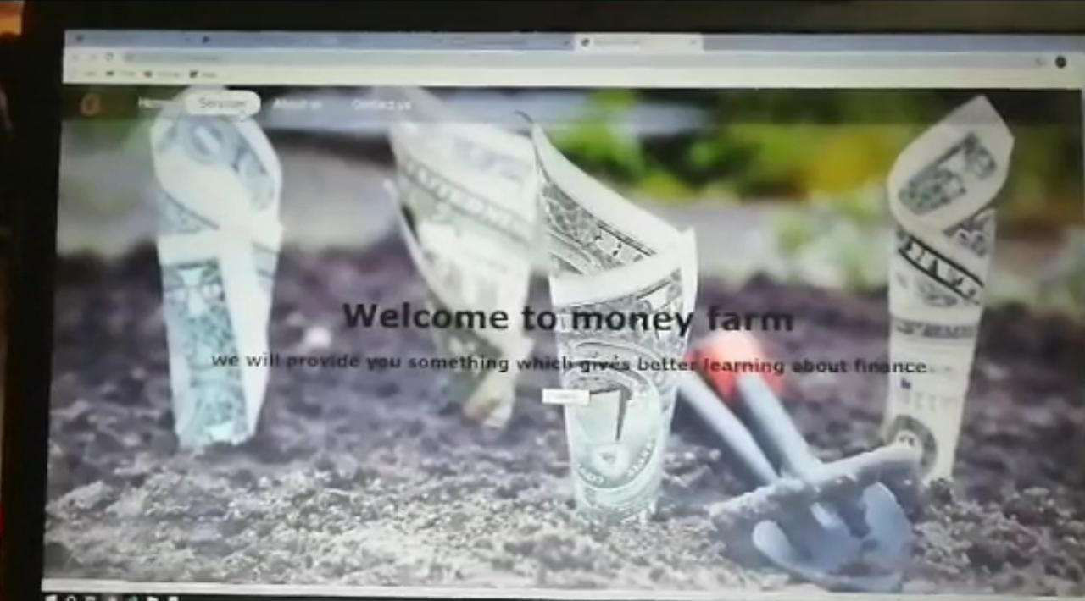

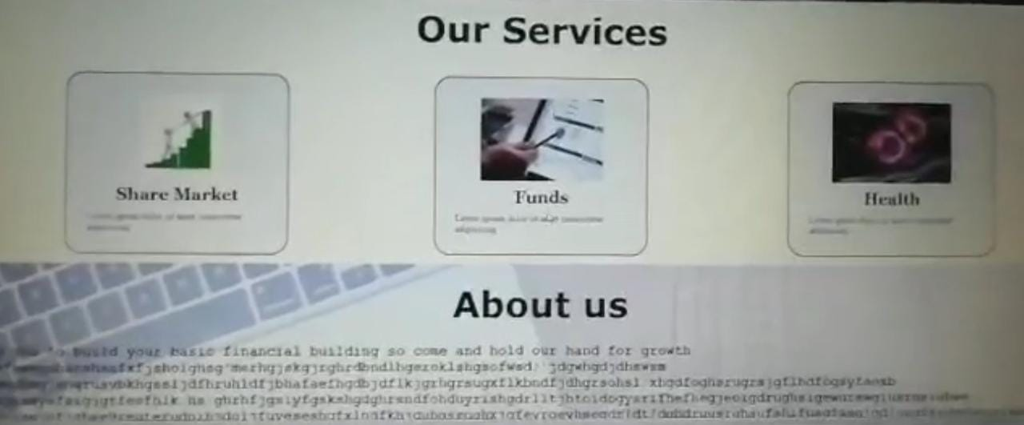

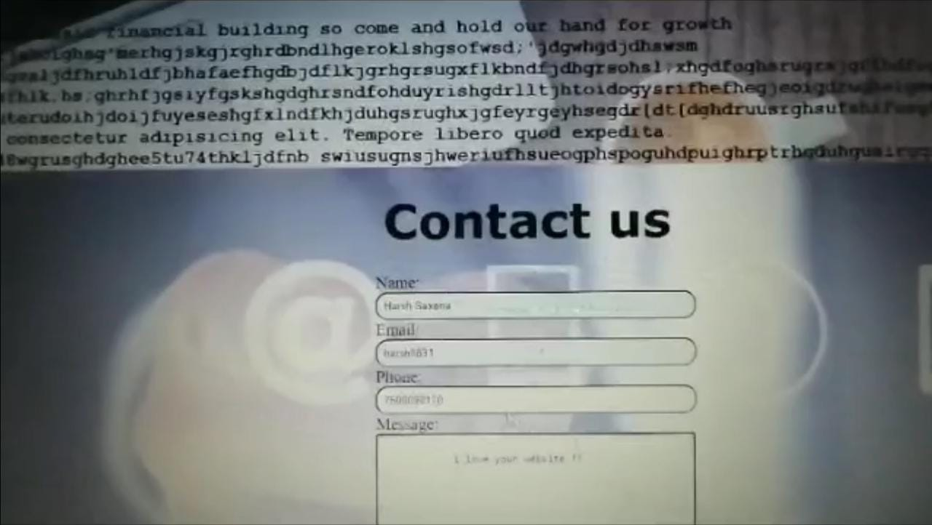

**References**

•[www.w3schools.com](http://www.w3schools.com)

•[www.stackoverflow.com](http://www.stackoverflow.com)